KHWOPA ENGINEERING COLLEGE
ASSESSMENT – 2062 (EVEN)

LEVEL:- B. E. (Computer/Elx. & Comm.) I/II
SUBJECT:- BEG123EL, Electrical Engineering I
FULL MARKS:- 80
TIME:- 03:00 hrs. PASS MARKS:- 32
Time: 3:00 hrs

Attempt any FIVE Questions.

1. [a] What are the effect of internal resistances in the terminal characteristics of the sources. 4

[b] The resistance of a bulb filament is measured as 528Ω when it is not in operation at room temperature of 25⁰C. After lighting the bulb for one minute, the resistance of the bulb is measured as 550Ω. Calculate the temperature of the bulb, given that the temperature coefficient of resistance of the filament is 35×10⁻⁴ per ⁰C at 0⁰C. 4

[c] Using Kirchoff’s Laws, Find I_{x}, R_{x}, and V_{x} 8
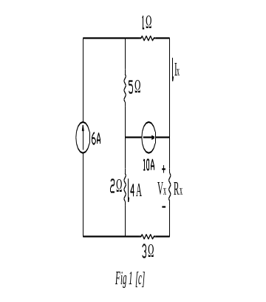

2. [a] State maximum power transfer theorem. 3

[b] Find the equivalent resistance across the terminals a–b. 8
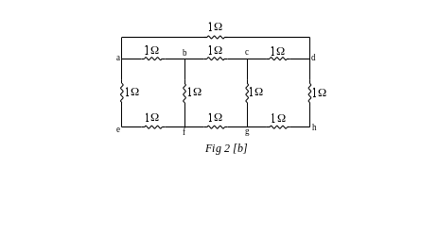
[c] Find the Thevenin’s equivalent circuit across the resistance R_{L}. 5
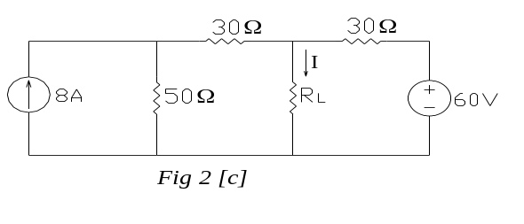

3. [a] State Norton’s theorem. 3

[b] Find the current through all the resistors using nodal analysis. 5
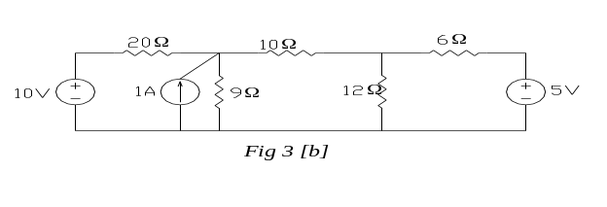

[c] Find the current through 30W resistor using super position theorem. 8
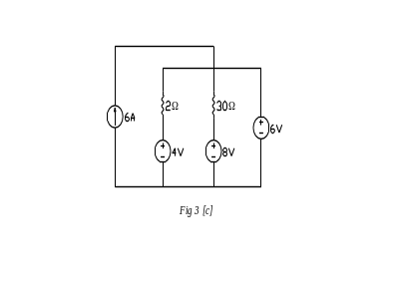
4. [a] State Faraday’s Laws of Electromagnetic Induction. 3

[b] Prove that the average power consumed by a purely inductive circuit is zero. 5

[c] An AC network consists of parallel combination of impedances Z₁=(4+j8)Ω and Z₂=(2-j16)Ω connected in series to Z₃=(4+j3)Ω. If the current through Z₃ is (25-j0)A, draw the complete phasor diagram, determining all the branch currents, voltages and the total voltage. Calculate the active and reactive power of the circuit. 8

5. [a] What do you understand by electrical resonance. Derive the expression for resonance frequency for a parallel RL-C circuit. What is the impedance of this circuit at resonance? 2+6

[b] A star connected balanced three phase load of impedance (8+j6)Ω per phase is connected to a 3-Φ, 230V supply. Find
i) line current
ii) power factor
iii) total power consumed
iv) total reactive power
v) apparent power per phase.
Draw the complete phasor diagram. 8

6. [a] Explain two wattmeter method of measurement of 3-Φ power. 4

[b] Differentiate between star connection and delta connection in three phase systems. 4

[c] A coil draws a current of 5A when connected to a 20V DC supply. When this coil is connected to a 50Hz, 25V supply, it draws 5A rms current. Calculate 8
i) inductance and resistance of the coil
ii) power factor of the coil
- active, reactive and apparent power of the coil when connected to 100V, 50 Hz supply.

*****

